**THIẾT KẾ CƠ SỞ DỮ LIỆU TRONG VISUAL BASIC**

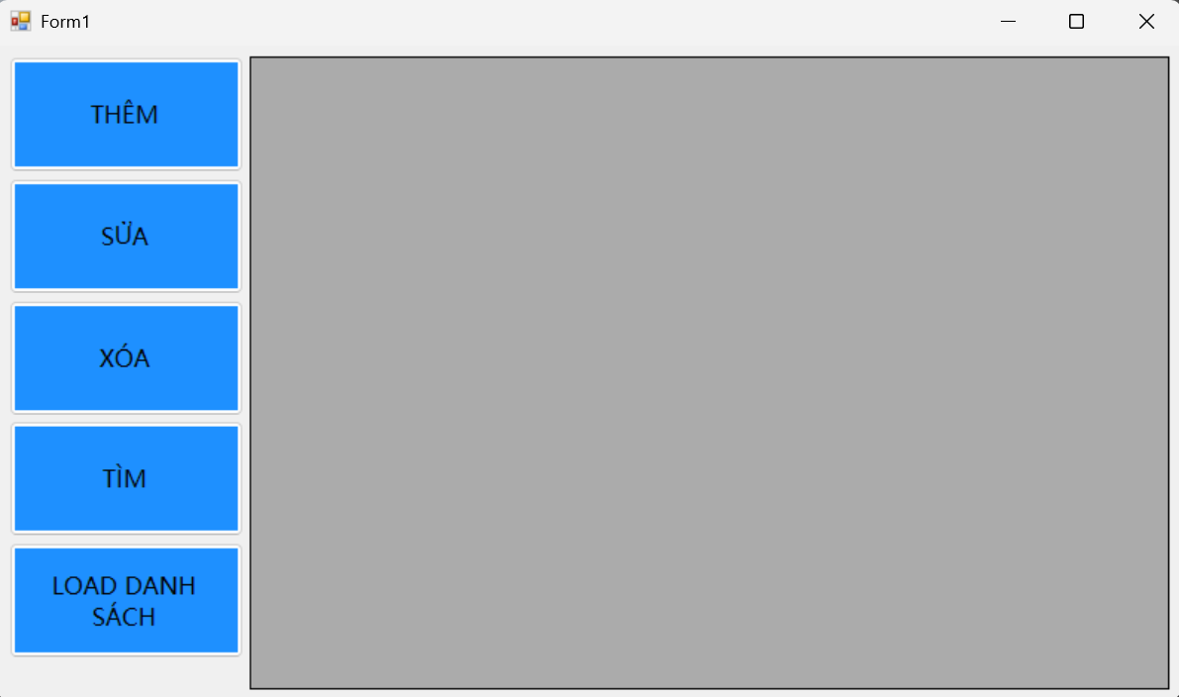

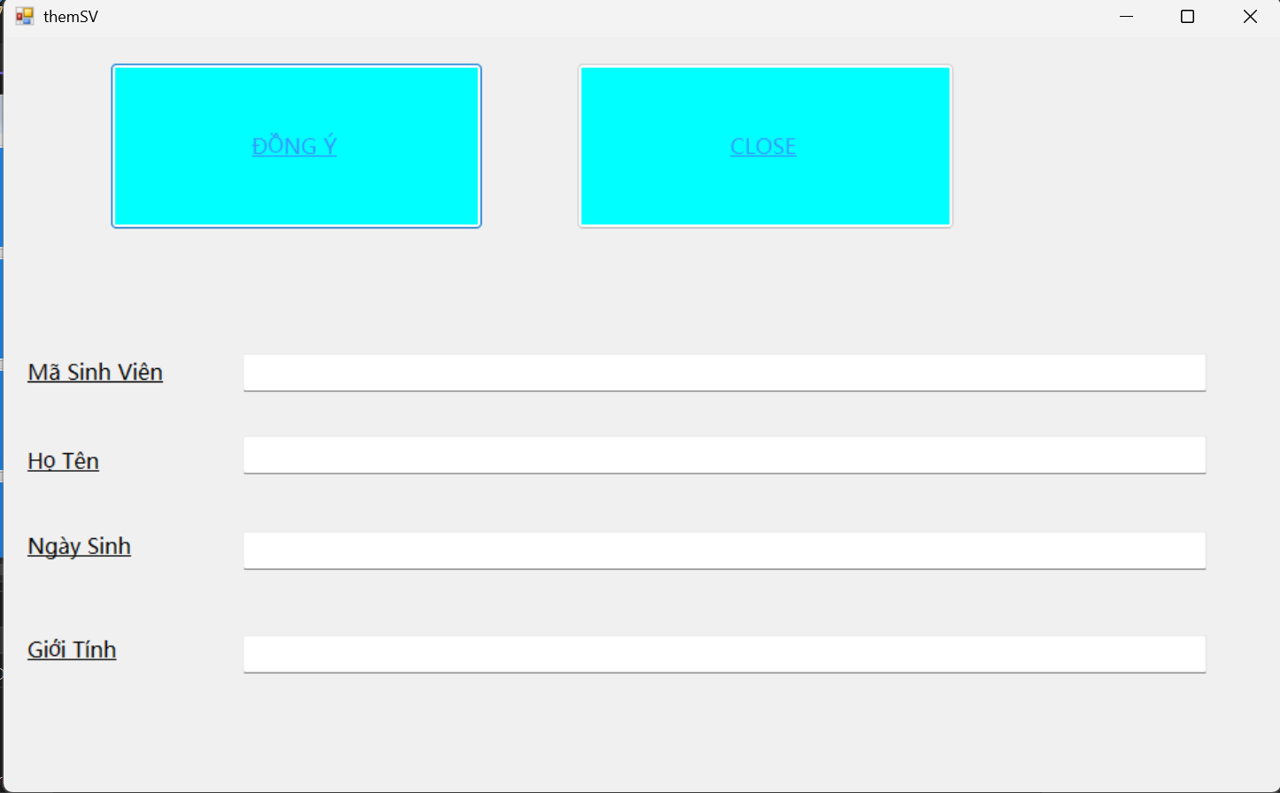

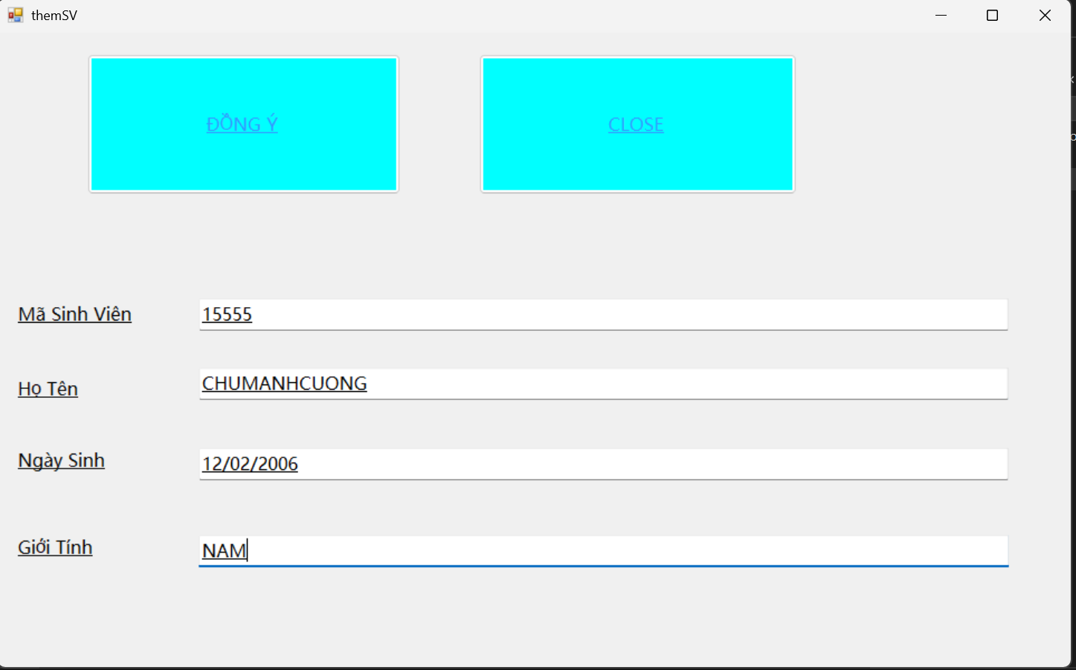

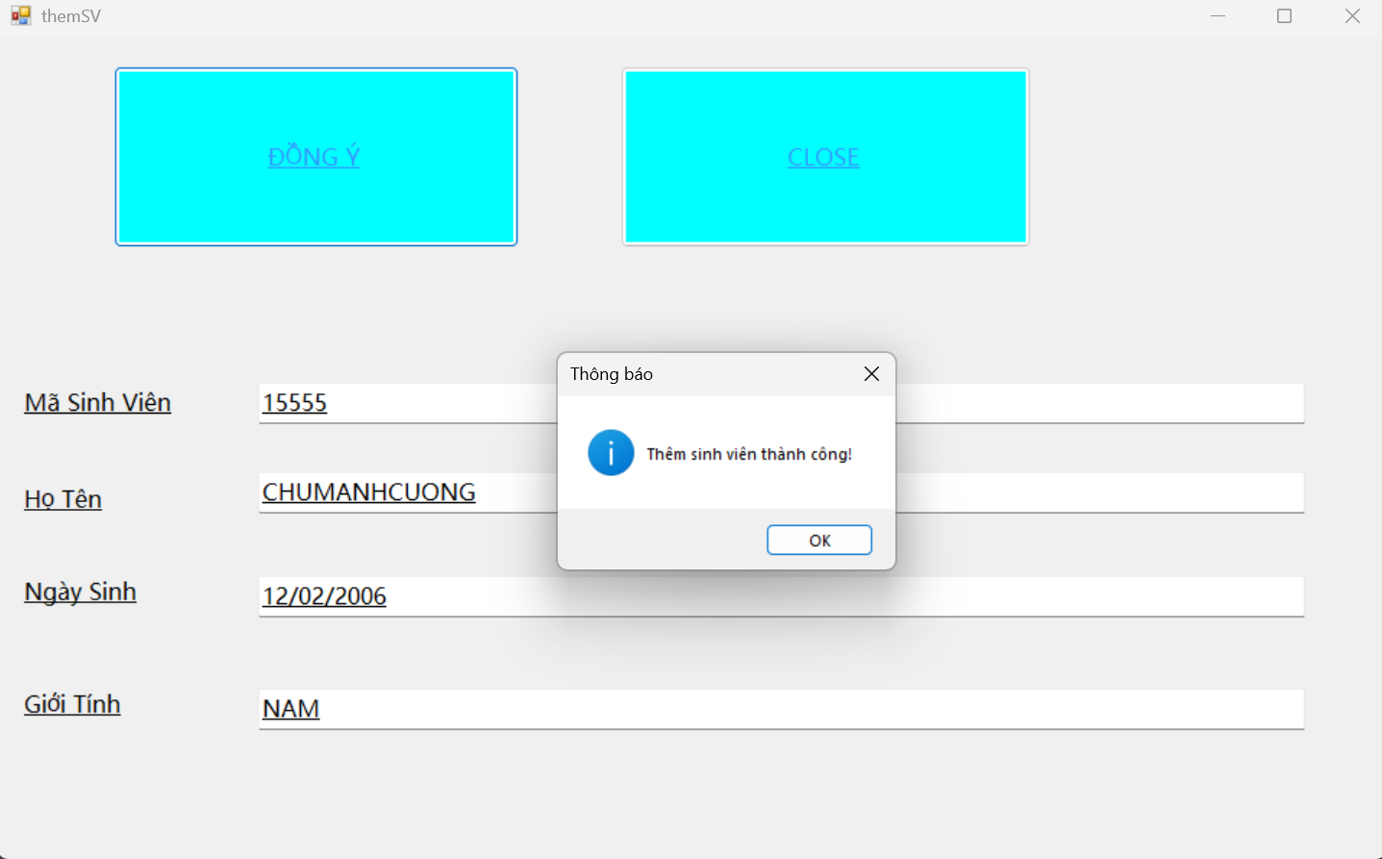

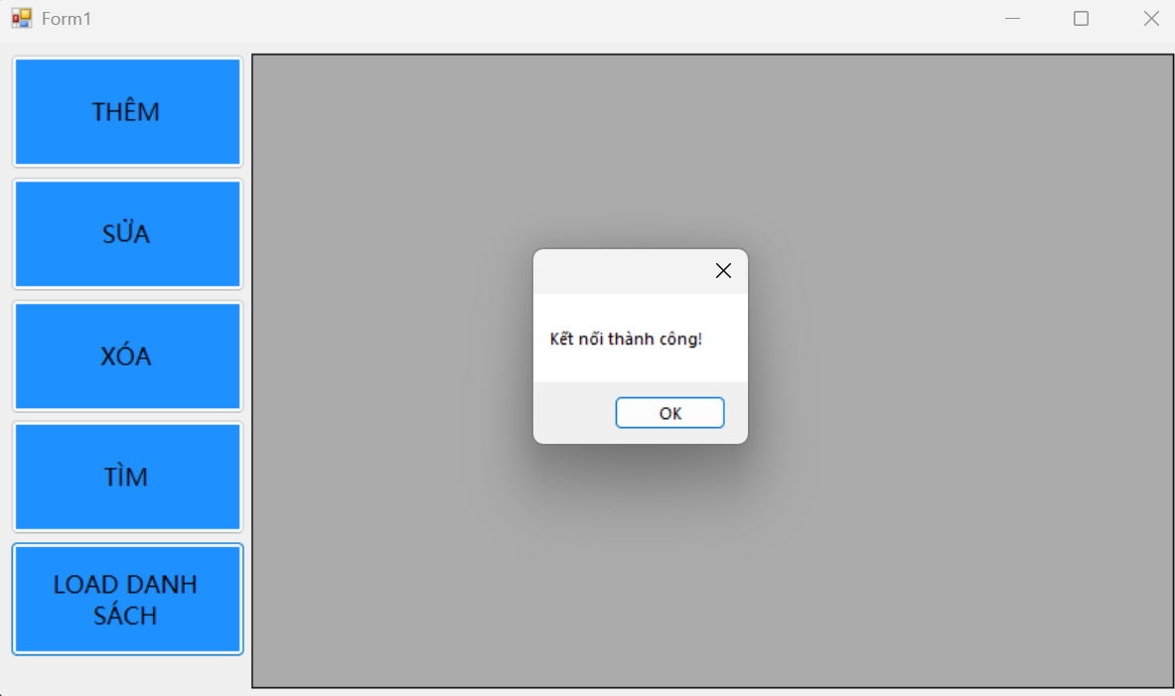

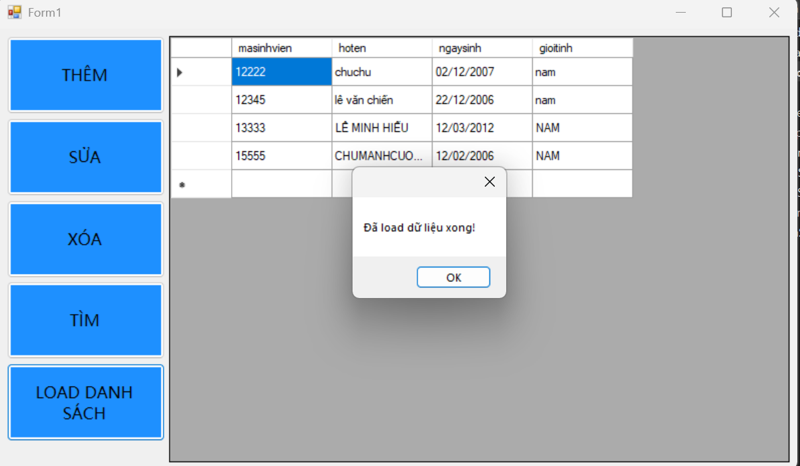

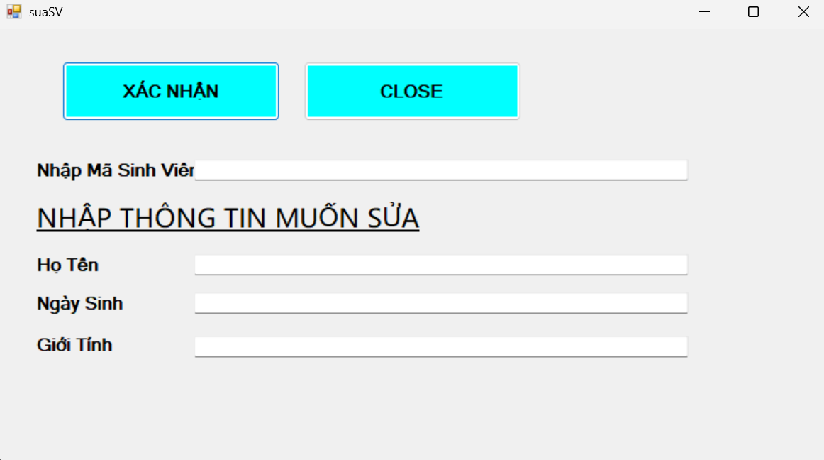

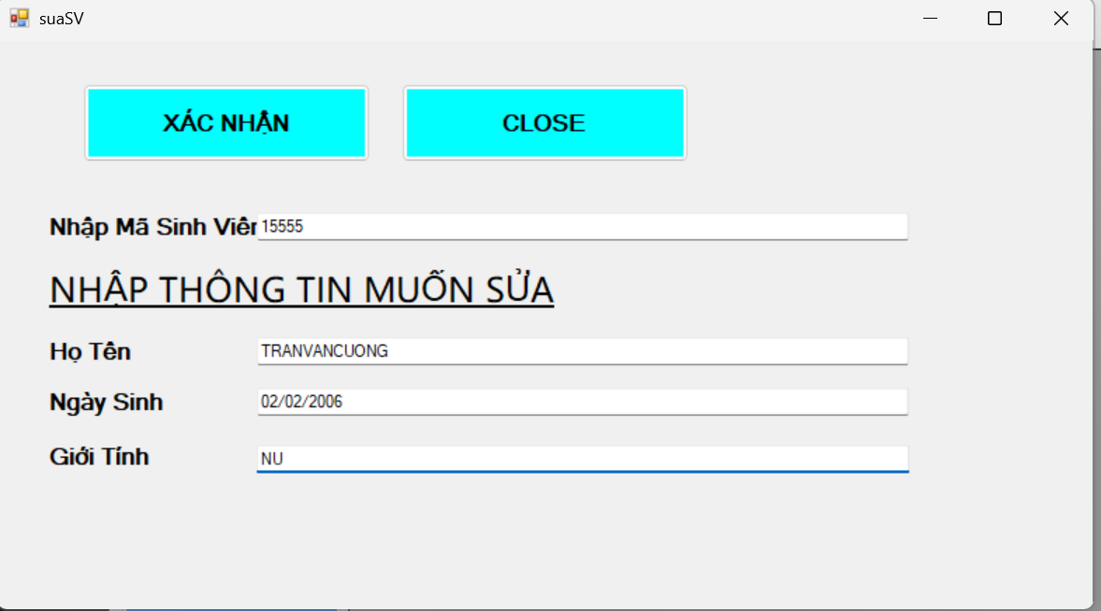

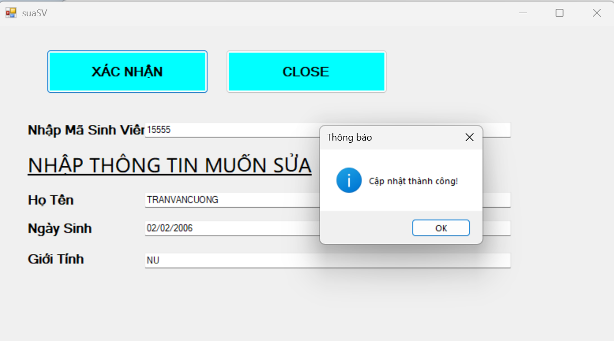

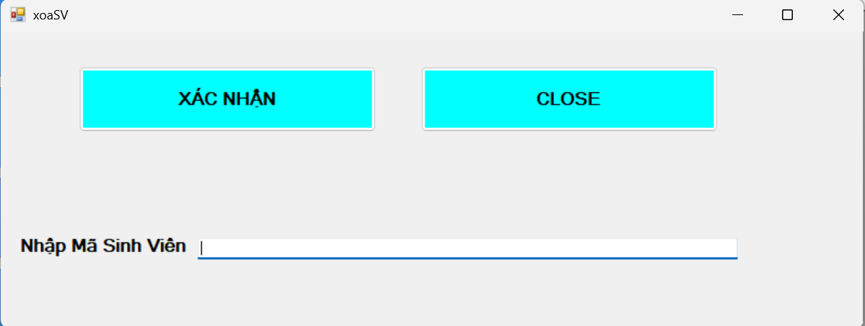

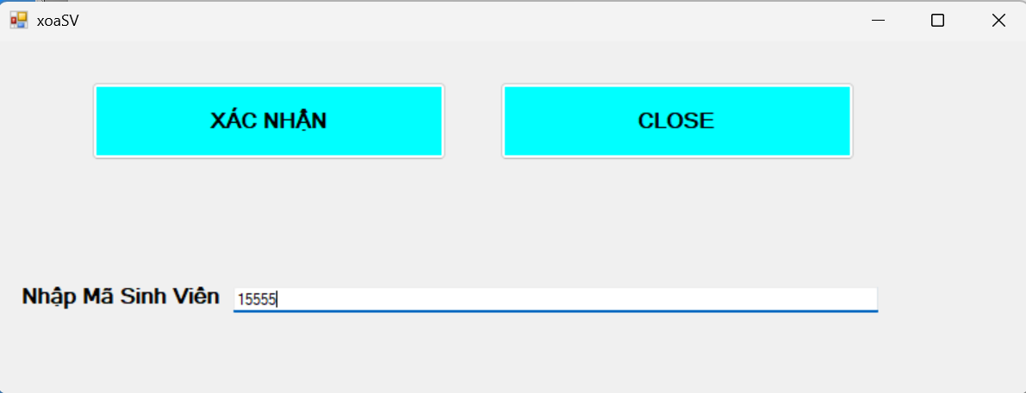

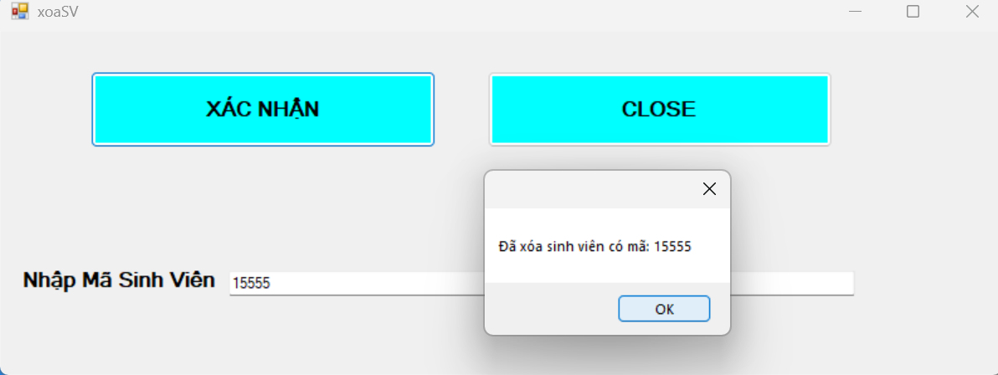

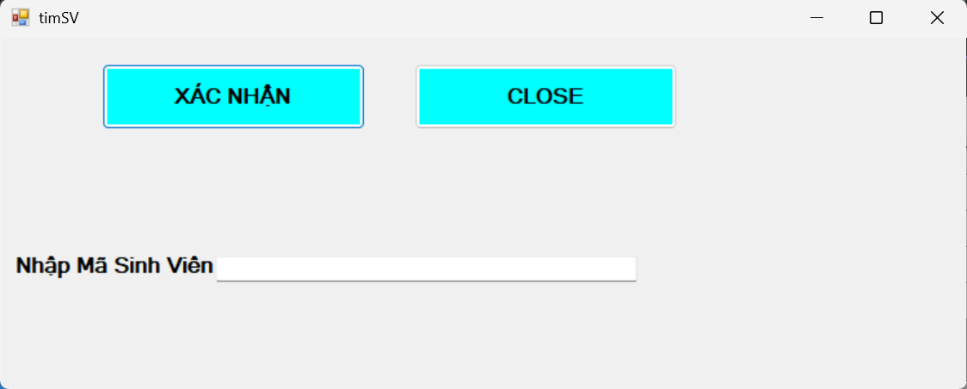

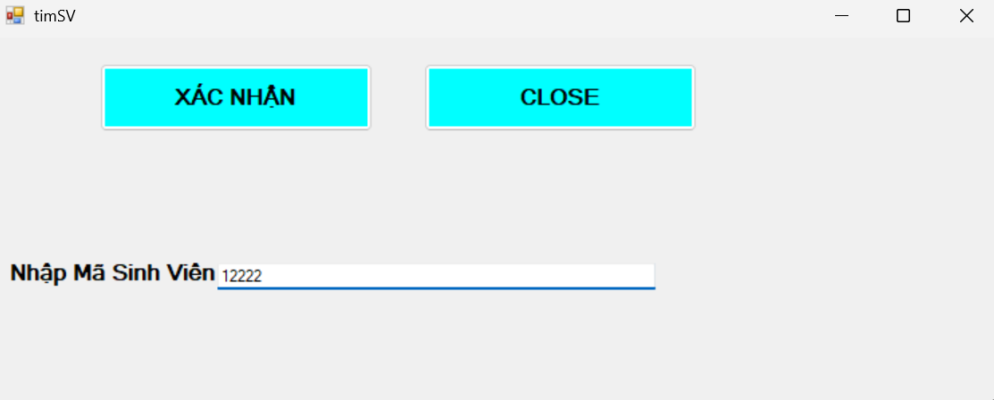

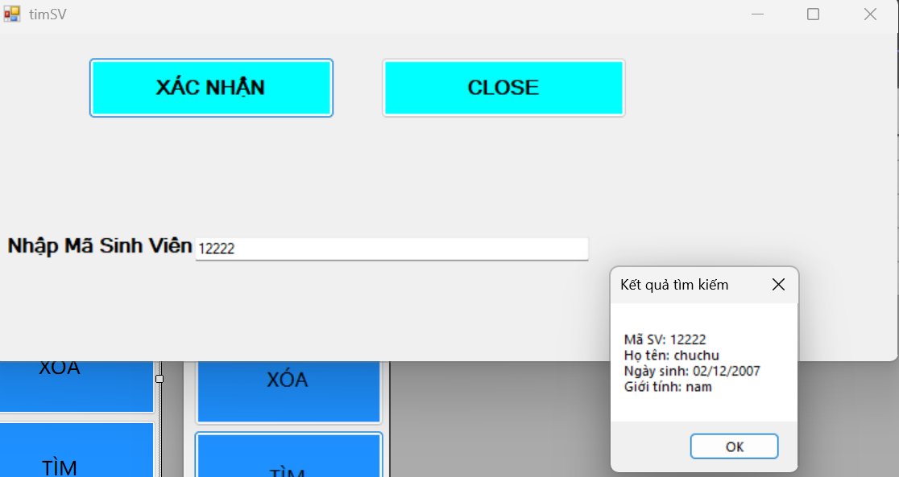

**FORM chính**

Imports System.Data.SqlClient

Public Class Form1

Private Sub Button1_Click(sender As Object, e As EventArgs) Handles Button1.Click

Dim a As New themSV()

a.Show()

End Sub

Private Sub Button2_Click(sender As Object, e As EventArgs) Handles Button2.Click

Dim a As New suaSV()

a.Show()

End Sub

Private Sub Button3_Click(sender As Object, e As EventArgs) Handles Button3.Click

Dim a As New xoaSV()

a.Show()

End Sub

Private Sub Button4_Click(sender As Object, e As EventArgs) Handles Button4.Click

Dim a As New timSV()

a.Show()

End Sub

Private Sub Button5_Click(sender As Object, e As EventArgs) Handles Button5.Click

Dim connectionString As String = "Data Source=PC-CUA-CHIEN;Initial Catalog=quanlysinhvien;Integrated Security=True"

Using conn As New SqlConnection(connectionString)

Try

conn.Open()

MessageBox.Show("Kết nối thành công!")

Dim sql As String = "SELECT * FROM thongtinsinhvien"

Dim cmd As New SqlCommand(sql, conn)

Dim adapter As New SqlDataAdapter(cmd)

Dim table As New DataTable()

adapter.Fill(table)

DataGridView1.DataSource = table

MessageBox.Show("Đã load dữ liệu xong!")

Catch ex As Exception

MessageBox.Show("Lỗi: " & ex.Message)

End Try

End Using

End Sub

Private Sub Form1_Load(sender As Object, e As EventArgs) Handles MyBase.Load

End Sub

End Class

Form thêm

Imports System.Data.SqlClient

Public Class themSV

Dim connectionString As String = "Data Source=PC-CUA-CHIEN;Initial Catalog=quanlysinhvien;Integrated Security=True"

Private Sub Button1_Click(sender As Object, e As EventArgs) Handles Button1.Click

Using conn As New SqlConnection(connectionString)

Try

conn.Open()

Dim sql As String = "INSERT INTO thongtinsinhvien (masinhvien, hoten, ngaysinh, gioitinh)

VALUES (@masinhvien, @hoten, @ngaysinh, @gioitinh)"

Dim cmd As New SqlCommand(sql, conn)

cmd.Parameters.AddWithValue("@masinhvien", TextBox1.Text)

cmd.Parameters.AddWithValue("@hoten", TextBox2.Text)

cmd.Parameters.AddWithValue("@ngaysinh", DateTime.Parse(TextBox3.Text))

cmd.Parameters.AddWithValue("@gioitinh", TextBox4.Text)

cmd.ExecuteNonQuery()

MessageBox.Show("Thêm sinh viên thành công!", "Thông báo", MessageBoxButtons.OK, MessageBoxIcon.Information)

Me.Close()

Catch ex As Exception

MessageBox.Show("Lỗi: " & ex.Message)

End Try

End Using

End Sub

Private Sub Button2_Click(sender As Object, e As EventArgs) Handles Button2.Click

Me.Close()

End Sub

Form sửa

Imports System.Data.SqlClient

Public Class suaSV

Dim connectionString As String = "Data Source=PC-CUA-CHIEN;Initial Catalog=quanlysinhvien;Integrated Security=True"

Private Sub suaSV_Load(sender As Object, e As EventArgs) Handles MyBase.Load

End Sub

Private Sub Button1_Click(sender As Object, e As EventArgs) Handles Button1.Click

Using conn As New SqlConnection(connectionString)

Try

conn.Open()

Dim sql As String = "UPDATE thongtinsinhvien

SET hoten=@hoten, ngaysinh=@ngaysinh, gioitinh=@gioitinh

WHERE masinhvien=@masinhvien"

Dim cmd As New SqlCommand(sql, conn)

cmd.Parameters.AddWithValue("@masinhvien", TextBox1.Text)

cmd.Parameters.AddWithValue("@hoten", TextBox2.Text)

cmd.Parameters.AddWithValue("@ngaysinh", DateTime.Parse(TextBox3.Text))

cmd.Parameters.AddWithValue("@gioitinh", TextBox4.Text)

Dim rows As Integer = cmd.ExecuteNonQuery()

If rows > 0 Then

MessageBox.Show("Cập nhật thành công!", "Thông báo", MessageBoxButtons.OK, MessageBoxIcon.Information)

Me.Close()

Else

MessageBox.Show("Không tìm thấy sinh viên với mã này!", "Thông báo", MessageBoxButtons.OK, MessageBoxIcon.Warning)

End If

Catch ex As Exception

MessageBox.Show("Lỗi khi cập nhật: " & ex.Message)

End Try

End Using

End Sub

Private Sub Button2_Click(sender As Object, e As EventArgs) Handles Button2.Click

Me.Close()

End Sub

End Class

Xóa

Imports System.Data.SqlClient

Public Class xoaSV

Dim conn As SqlConnection

Private Sub Button1_Click(sender As Object, e As EventArgs) Handles Button1.Click

Try

Dim masinhvien As String = TextBox1.Text.Trim()

If masinhvien = "" Then

MessageBox.Show("Vui lòng nhập mã sinh viên cần xóa!")

Return

End If

Dim sql As String = "DELETE FROM thongtinsinhvien WHERE masinhvien = @masinhvien"

Dim cmd As New SqlCommand(sql, conn)

cmd.Parameters.AddWithValue("@masinhvien", masinhvien)

Dim rowsAffected As Integer = cmd.ExecuteNonQuery()

If rowsAffected > 0 Then

MessageBox.Show("Đã xóa sinh viên có mã: " & masinhvien)

Else

MessageBox.Show("Không tìm thấy sinh viên có mã: " & masinhvien)

End If

Catch ex As Exception

MessageBox.Show("Lỗi khi xóa: " & ex.Message)

End Try

End Sub

Private Sub Button2_Click(sender As Object, e As EventArgs) Handles Button2.Click

Me.Close()

End Sub

Private Sub xoaSV_Load(sender As Object, e As EventArgs) Handles MyBase.Load

conn = New SqlConnection("Data Source=.;Initial Catalog=quanlysinhvien;Integrated Security=True")

conn.Open()

End Sub

End Class

Form tìm

Imports System.Data.SqlClient

Public Class timSV

Dim conn As SqlConnection

Private Sub Button1_Click(sender As Object, e As EventArgs) Handles Button1.Click

Try

Dim masinhvien As String = TextBox1.Text.Trim()

If masinhvien = "" Then

MessageBox.Show("Vui lòng nhập mã sinh viên cần tìm!")

Return

End If

Dim sql As String = "SELECT * FROM thongtinsinhvien WHERE masinhvien = @masinhvien"

Dim cmd As New SqlCommand(sql, conn)

cmd.Parameters.AddWithValue("@masinhvien", masinhvien)

Dim reader As SqlDataReader = cmd.ExecuteReader()

If reader.HasRows Then

Dim info As String = ""

While reader.Read()

info &= "Mã SV: " & reader("masinhvien").ToString() & vbCrLf

info &= "Họ tên: " & reader("hoten").ToString() & vbCrLf

info &= "Ngày sinh: " & Convert.ToDateTime(reader("ngaysinh")).ToString("dd/MM/yyyy") & vbCrLf

info &= "Giới tính: " & reader("gioitinh").ToString() & vbCrLf

End While

MessageBox.Show(info, "Kết quả tìm kiếm")

Else

MessageBox.Show("Không tìm thấy sinh viên có mã: " & masinhvien)

End If

reader.Close()

Catch ex As Exception

MessageBox.Show("Lỗi khi tìm kiếm: " & ex.Message)

End Try

End Sub

Private Sub timSV_Load(sender As Object, e As EventArgs) Handles MyBase.Load

conn = New SqlConnection("Data Source=.;Initial Catalog=quanlysinhvien;Integrated Security=True")

conn.Open()

End Sub

Private Sub Button2_Click(sender As Object, e As EventArgs) Handles Button2.Click

Me.Close()

End Sub

End Class